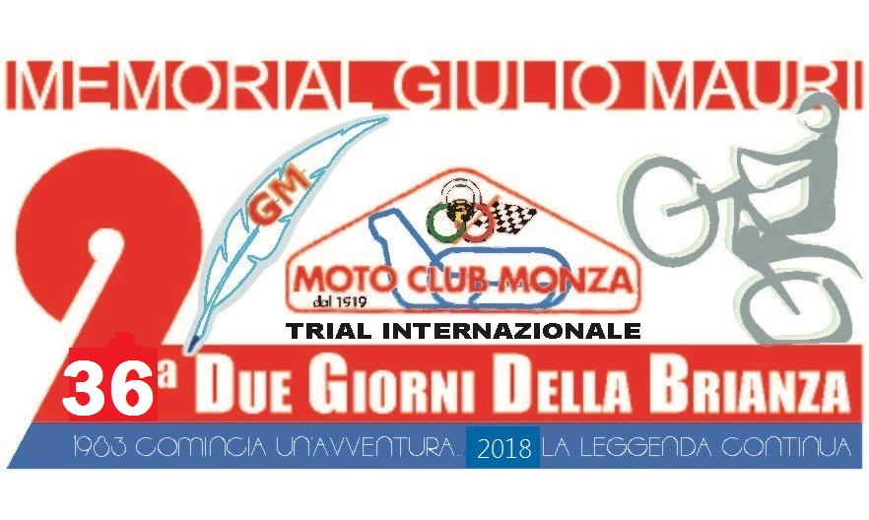

36th “TWO DAYS of BRIANZA” Memorial Giulio Mauri
INTERNATIONAL TRIAL
03-04th March 2018

Event’s Schedule
The Moto Club Monza call and organize, under the aegis of the Italian Olympic Committee and the regulations of the Italian Motorcycle Federation (FMI) and the International Motorcycle Federation (FIM), on Saturday 03th and Sunday 04th of March 2018 an International Trial, “36th Two Days of Brianza”. Admission to the race will be granted to all drivers in possession of permits issued by FMI, FIM or other federations that belongs to FIM Europe.

Departure and Arrival
Stendhal Sport Village, Dante street Oggiono (LC). (Front of Oggiono lake)
Geographic coordinates: long. 9°21'16.64"E – lat. 45°47'49.36"N

First Day - Saturday 03th March 2018
Start of competition from 10:00 a.m.
Drivers will depart every minute, following the progressive pit number. The total length of the track course is 8,0 km on two loops, with 15 no stop.

Second Day - Sunday 04th March 2018
Start of competition from 8:30 a.m.
The total length of the track course is 8,0 km on two loops, with 15 no stop.

Award Ceremony
Sunday 04th of March 2018, 05:30 p. m.

Categories Acknowledged
TOP - blu track International cat., TR 1, TR2
SUPER - green track cat. TR3, TR3/125, TR3 O
ENTRY - yellow track cat. TR4, Women
AMATORI - white track cat. TR5,
VINTAGE - white track All motorcycle with two shocks

INFORMATIONS: Tel + fax 039.325103 info@motoclubmonza.it
Moto Club Monza – Cso Milano, 39 20900 MONZA – MB (I)
www.mototrial.it www.motoclubmonza.it

