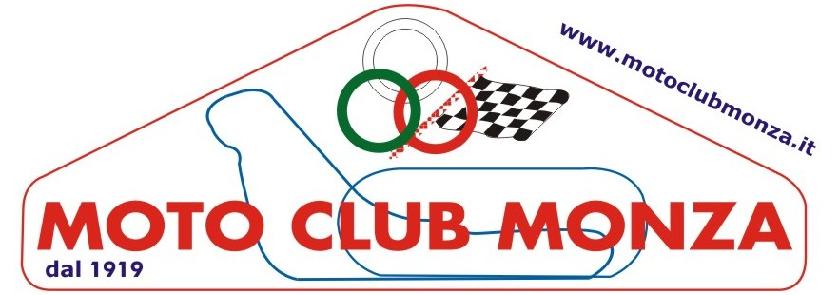

TRIAL EUROPEAN CHAMPIONSHIP 06.07.2013
TRIAL WORLD CHAMPIONSHIP 07.07.2013
BOOKING FORM AUTOCARAVAN PARKING
COST PER NIGHT € 15.00

OPEN FROM 04.07-2013 TO 07-07.2013

SURNAME | NAME
e-mail address: | Tel nr.

AUTOCARAVAN TYPE | NUMBER PLATE

DAY OF ARRIVAL

NOTE

MOTO CLUB MONZA Via Ardigò, 11 20900 MONZA (MI)
fax +39 039.325103
www.motoclubmonza.it info@motoclubmonza.it

